Operation Totalize
33
MILITARY
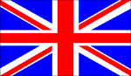
2nd BRIT 1ST CAN
AIR POWER
Jabos: +1 1st Can;
Carpet Bombing
RESOURCES
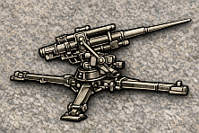
2 xFlak 88s*
*Each marker can be immediately deployed to the map or placed in Strategic Reserve box
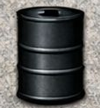
Lose 1

ORDERS: 3 Actions
+1 Defense Strength 1st CAN
+2 Montgomery
Operation Totalize was an offensive launched by Allied troops of the First Canadian Army from August 8 to August 13, 1944. The intention was to break through the German defences south of Caen on the eastern flank of the Allied positions in Normandy and exploit success by driving south to capture the high ground north of the city of Falaise. The overall goal was to precipitate the collapse of the entire German front, and cut off the retreat of German forces fighting further west.

